A000-Afr-Ghana-Ashante-Asesedwa Stool, Wasadwa type-Before ca. 1950

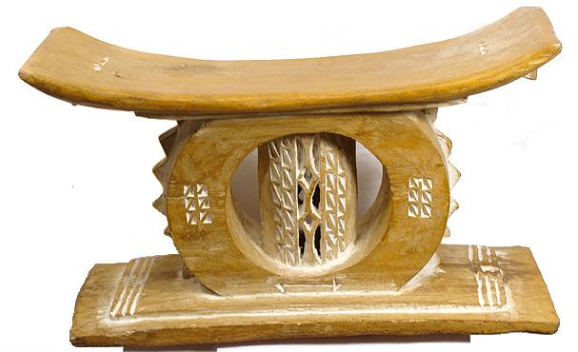

Fig. 1. Afr-Ghana-Ashante-Asesedwa Stool, Wasadwa type-Before ca. 1950

Case No.: 6

**Accession No.**

**Formal Label:** Afr-Ghana-Ashante-Asesedwa Stool, Wasadwa type-Before ca. 1950

**Display Description:**

This is an important stool the design of which was made as a presentation to the Wassaw chief by the king of the Ashante (Asihiene 1978:, p. 64 and Fig. 21, p. 69). After selecting fresh sese wood the master carver shaped the wood into the form of a stool and then selected the form of the symbolism to be incorporated into its design. Local blacksmiths provided the necessary iron tools for this enterprise. Stools start out as a white wood and through time take on a burnished and well-worn golden hue. This stool was finished to a smooth gloss using leaves that have a rough texture like fine "00" sandpaper. A well-carved stool such as this serves multiple purposes in addition to providing a well-designed seat to sit upon. Among the Ashante stools take their name Asesedwa from the wood (sese) out of which they are carved. Stools' designs change with families and generations and gifting. This stool was designed as a gift to Wassaw chief and so has his symbolism incorporated into it that adumbrates the chief's unique spirit. The symmetrical placement of six chevron-like designs on either side of the central pillar are repeated in the central pillar itself, in the six figures surrounding the central oval, in the double arrow at the base, the two triangles on the underside of the seat and in the six triangles on the surface of the seat itself. All of these triangular chevron-like symbols represent the protective powers surrounding the "X" shaped figures of the central pillar, which symbolize the major male entourage of the kingly office. These designs are mirrored on the opposite side of the stool. It is intended that the symbolism of the stool becomes not only the property of the owner but also the identification of the owner's spirit and being. With this ontological symbolism it is important to prevent someone other than the owner to assume its ontological being by sitting on it or to allow a malevolent spirit to take charge of the stool and with it the owner's spirit. Therefore, often stools will be seen with their upper corners worn from being leaned up against the wall or laid down on their sides to prevent unauthorized use of it, as evident in this specimen.

**LC Classification:**

**Date or Time Horizon:** Before ca. 1950

**Geographical Area:** Ahwaa near Kumasi

**Map:**

**GPS coordinates:**

**Cultural Affiliation: Ashante**

**Media:** Made from Sese wood and kaolin pigment probably in the village of Ahwaa near Kumasi where expert stool carving is practiced.

**Dimensions:** Height: 13 inches. Width: 22 inches

**Weight:**

**Condition:** Excellent; tribally used

**Provenance: Acquired from an Ashante chieftain**

**Discussion:**

**References:**

Asihene, Emmanuel V. 1978. *Understanding the traditional art of Ghana.* Rutherford, Madison, Teaneck: Fairleigh Dickinson University Press; London: Associated University Presses.

[Sarpong](http://www.jstor.org.libproxy.mit.edu/action/doBasicSearch?Query=au%3A"Peter+Kwasi+Sarpong"&wc=on)[i](http://www.jstor.org.libproxy.mit.edu/stable/40456847?&Search=yes&searchText="Sese+tree"&list=hide&searchUri=%2Faction%2FdoBasicSearch%3FQuery%3D%2522Sese%2Btree%2522%26gw%3Djtx%26acc%3Don%26prq%3D%2522Sese%2B%2522%26Search%3DSearch%26hp%3D25%26wc%3Don&prevSearch=&item=1&ttl=1&returnArticleService=showFullText), [Peter Kwas](http://www.jstor.org.libproxy.mit.edu/action/doBasicSearch?Query=au%3A"Peter+Kwasi+Sarpong"&wc=on). The Sacred Stools of Ashanti, Anthropos, Bd. 62, H. 1./2. (1967), pp. 1-60.

